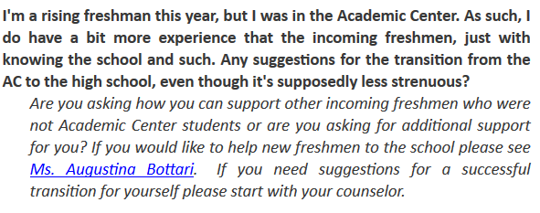

This was found on the whitney young weekly, september 10 2017

This is a personal call. I will give 1 pepe to whoever finds out who did this

its so fucking cringy

Also, we need to come up with our own question sometime. Make it on the edge of acceptable.

Also, Ill leave other dumb questions

